(Approx. 773 words)

Make Life Easier with Office Templates
Author: Nancy DeMarte, 2nd Vice President, Sarasota Technology Users Group, FL
August 2019 issue, STUG Monitor
www.thestug.org
education (at) thestug.org

It never hurts to make life easier, especially when we have necessary tasks to do. Recently, I revisited an old, but underused feature of Office: Templates. I was surprised to find many new templates and easy ways to search for, create and personalize them.

What is a template? It is a predesigned document that you can customize. You provide content like text or pictures within a professionally designed structure. Most templates include guided instructions within the template. Office templates cover a range of different purposes: business or personal cards, brochures, flyers, calendars, and more. Templates are available in Word, PowerPoint, Excel, and Publisher in both the Windows and Mac Office suites.

I was looking recently for a new design for my personal cards. When I opened the Word application, I saw several templates next to and below Blank document, with many more available free online.

I typed ‘Personal Cards’ into the Search box and pressed Enter to reveal a collection of card templates. I chose one called “Earth tones business cards” and clicked it. Then I took a few minutes to read the descriptive details and wrote down the card size and product numbers for card paper compatible with my cards. Finally, I clicked Create to open the template.
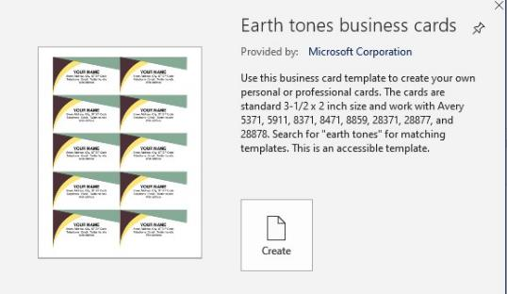

Customizing this template was easy. I clicked inside the top left card, selected YOUR NAME and typed my own name in its place. When I pressed Enter, all the other cards on the template displayed my name, too. The same was true for the other data. The whole process took no more than ten minutes. Now I had a sheet of professional-looking cards ready to be printed as soon as I purchased one of the compatible card packages at an office store.

Templates in Excel: Next, I opened Excel to see what templates were available. I wanted to find a calendar with a page for each month to personalize for my extended family. In Excel, I found a calendar I liked called Seasonal Photo Calendar.
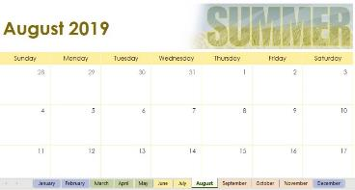

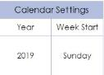

I read the details carefully before clicking Create. Once I downloaded the calendar, I began by clicking January at the bottom of the screen. Then I checked the Calendar settings for Year (2019), and Week Start (Sunday) to make sure all dates in 2019 would appear on the correct days of the week. Of course, this can be modified for the next year.

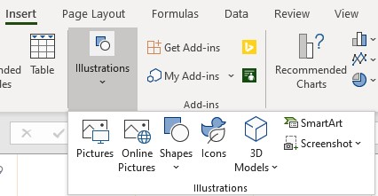
Then I began to add text and/or pictures to the important dates for each month. I clicked a date on the calendar, then clicked Insert tab > Illustrations > Pictures (or other graphics). To add text, I double-clicked in a date square and typed. I made pictures smaller by dragging from a corner toward the center.

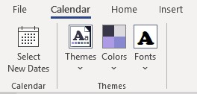
Many calendar templates allow you to change colors, fonts, and themes. Some only let you change the text. If you are working with a calendar template, select what you want changed and look for the Calendar tab on the ribbon, as shown. If you find you have the wrong dates for the days of the week, click Select New Dates.

Templates in PowerPoint are called themes. These include the background design, font, and color scheme. There are also templates for entire PowerPoint presentations. All you need to do is change the text and replace the pictures with your own. This can be a lifesaver if you need a presentation quickly.

Publisher Templates offer a wide variety of templates. When I searched for Cards, I got greeting cards, invitations, plus business and personal cards. These are worth exploring.

Tips: You might ask how an Office template differs from an Office file (document, spreadsheet, or presentation)? Templates keep their original structure, no matter how much they are customized. To distinguish them from normal files, they have a unique file extension. In Word, for example, a document extension is .docx, while a Word template extension is .dotx (or dotm, if macro-enabled). Your search will show you templates, but when you click Create, the template becomes a document, leaving the template intact.

You can create templates as well as use them. If you have personalized a Word document, for instance, and saved it with a .dotx extension, it is now a template. When you use it, though, be sure to save it as a Word document (.docx extension), or your original template will be lost.

Next time you need for a professional-looking document or other project, try using a template. You may find it easier than you thought.

